AGAR 2026 requirements
This is a briefing document to enable you to better prepare for the next council meeting. I’ve tried to balance keeping it shortish with the need to explain clearly. No doubt it’s not perfect so if you need any clarification please contact me.
Swallowcliffe Parish Council does not meet several obligations. A format change to the AGAR audit in 2026 means that several IT-related requirements have been consolidated into a new section where they are now clearly and explicitly stated as required, whereas previously they were only implied. This means they will now be expressly audited.
Requirements:
- Use a council-owned domain name for email.
- Operate a web site that meets WCAG 2.2AA standards.
- Include documentation required under the Freedom of Information Act 2000, comply with General Data Protection Regulation and Data Protection Acts.
- Maintain an IT policy.
I’ve collated them together in this document.
In short, if we do not meet these requirements we are at risk of failing the next AGAR audit. We will need to decide upon actions or a plan consider these extra costs in the precept planning.
I’ll itemise actions in the council meeting agenda.

Actions summary
- Purchase a .gov.uk domain name.
- Use <name>@<something>.gov.uk email addresses.
- Have the web site meet accessibility standards.
- Register with the Information Commissioner’s Office.
- Update our Publication Scheme.
- Update our GRPR policy document.
- Create an IT Policy document.

Domain name
We’re:
- recommended to have a <something>.gov.uk domain name, and
- required to have cllr_<name>@<something>.gov.uk email addresses.
We can have one without the other, though it would only be confusing.
<something> could be swallowcliffe-pc or swallowcliffeparishcouncil.
(Only about 30 of the 150 email addresses in the Wiltshire local council flood working group distribution list are .gov.uk, so we are not alone, but a domain name provider I spoke to says he is getting several enquiries a day from local councils).

General
The .gov.uk domain was specifically created for use by central, devolved, and local UK public sector organisations. Parish councils are eligible to use the .gov.uk domain name for websites and emails.
The benefits for parish councils include having:
- the trusted and professional .gov.uk brand that people will recognise
- increased transparency and security compared to personal email accounts
- the ability to manage email accounts by removing staff when they leave
- easy access to staff email accounts to fulfil Freedom Of Information obligations
- continuous central government monitoring for potential security vulnerabilities
- better legal protection because it’s based in a UK jurisdiction
The clerk of the parish council is the registrant. This role means control over the domain name and all related services, such as emails and the website. The supplier who registers and manages the gov.uk domain is called a registrar. The domain name must be registered to the council, not an individual.

Us
Our current domain name swallowcliffeparishcouncil.org.uk is managed by Heart Internet and expires at the end of May 2027. Heart Internet is not a permissible registrar for .gov.uk domain names, so we’ll need a new registrar (see Pricing below).
If we were to get www.swallowcliffeparishcouncil.gov.uk we could keep swallowcliffeparishcouncil.org.uk and have them point to the same web site. This is recommended. We can choose to renew (or not) swallowcliffeparishcouncil.org.uk at renewal time.

Email addresses
All permanent staff and councillors must use individual .gov.uk email accounts rather than free personal email accounts to improve professionalism, maintain transparency and to increase security.

Pricing
CloudNext who already manage the domain and provide hosting for >800 councils would provide:
- Domain name for £50 + VAT / year. Free for first year.
- Emails: 25 mailboxes of max 2GB each - £49.99 + VAT / year. Free for first year.
Easyspace who claim to be the number one choice cost:
- Domain name: £33.40 + VAT / year.
- Emails: 5 mailboxes of max 12GB each - £108 + VAT / year. Additional mailboxes £24 + VAT / year.
(With discounts for purchasing for more than one year.
Aubergine
Predicated on new web site (see WCAG below)
- Domain name and emails bundled with web hosting

WCAG
Web Content Accessibility Guidelines (WCAG) is a set of guidelines for web sites to make them accessible to persons with disabilities. Services must achieve WCAG 2.2 level AA as part of meeting government accessibility requirements.
Our fails with ~50 issues. Mostly simple things that are easily corrected, for example colour contrast and hints for screen readers (missing attributes on the HTML that are easily added).
Here’s a screenshot showing issues with the home page.
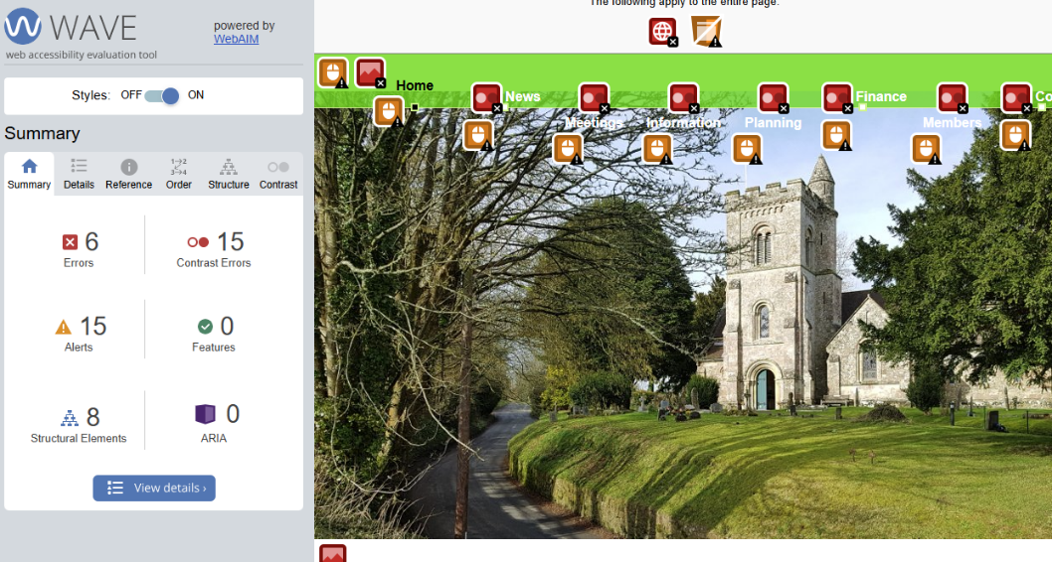

As an aside, https://www.swallowcliffevillage.uk/ also breaks accessibility regulations:
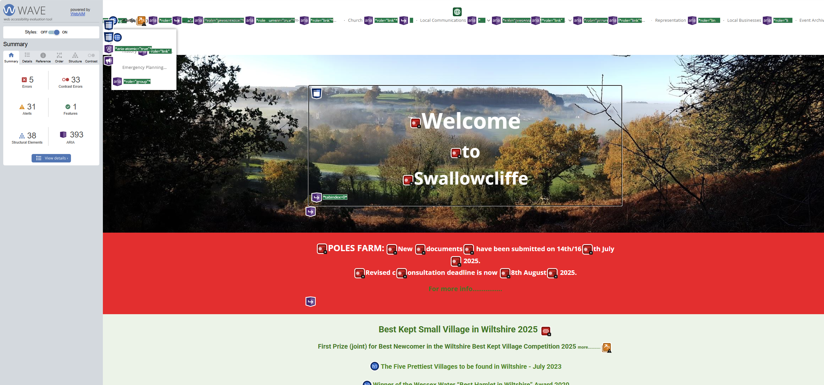

Options as I see it:
- Don’t fix.
- Pay Fossil Design. They have informed me that to do this would require us to itemize all the issues we wish to be fixed so seems to me to be impractical.
- Contract someone else to do it. Fossil Design have kindly provided the web site’s source code to me so that it can be fixed offline, and they are happy to upload fixed code for free. Previously a web professional, I am happy to make the corrections at a reasonable rate. Obviously, this would mean that I would have a pecuniary interest in any decision, but I believe I am best placed to do it since I can make immediate decisions on how to fix and quickly show mock-ups to councillors. A rough estimate would be a day’s work.
- Create a brand-new web site based on a template that meets the WCAG requirements provided by another part – E.G.
  - Parish Council Websites. Ansty’s website is provided by them. A package we would need would be £749.
  - Aubergine. Tarrant Monkton and Launceston Parish Council’s web site is provided by them. Their base is £499 + VAT for the first year, £299 + VAT for subsequent years (see their optional extras).
A new website would require the transfer of existing content. Aubergine would charge £25 + VAT per hour.
We also must decide whether to pay a 3rd-party service to check for WCAG compliance, or to use free tools as I have done above.

FOI / GDPR / DPA

FOI
We are required to be registered with the Information Commissioner’s Office, but we are not.
Under the Data Protection (Charges and Information) Regulations 2018, any organisation that determines the purpose for which personal data is processed (i.e. a data controller) must be registered.
We must register (£25) and pay the annual fee via the ICO’s registration portal.
We don’t need a Data Protection Officer (DPO)—the legislation was amended to remove that requirement for parish councils.
We are required to have a publication scheme. We do have one on the website, but it needs to be checked and updated (with new clerk contact information, at least).

GDPR / DPA
Under AGS Assertion 10, we must comply with their legal and statutory obligations under UK GDPR and the Data Protection Act 2018, process personal data lawfully, fairly, and in line with the prescribed data protection principles, and recognise their role as both a Data Controller and a Data Processor.
Here’s a list of recommended compliance steps. We already have some of them in place, though out-of-date, and we should go through step-by-step to ensure compliance.
- Document the personal data we process (data map), why we process it (purpose), reasons for processing (lawful bases), who has access to the data, how and where it’s securely stored and how long we keep it for.
- Risk-assess all personal data, identify areas of concern and put in place mitigation measures and effective ways of working.
- Have relevant policies and documents in place, including a bespoke Privacy Notice, data protection policy, ‘Appropriate Policy Documents’, data retention policy, Bring Your Own Device (BYOD) policy, ‘just in time’ notices, and more.
- Provide appropriate levels of training to staff and councillors, including regular refresher training.
- Respond to data protection requests (as well as FOI and EIR requests), including Subject Access, Right to Erasure, and more.
- Comply with the ‘Right to be Informed’ and put in place ‘appropriate organisation and technical measures to ensure compliance.
(Our GDPR policy document was last updated in 2021. It’s not on the council’s website. I’ve attached it to the email along with this document for you to review.)

Swallowcliffe Parish Council IT Policy
The Smaller Authorities’ Proper Practices Panel (SAPPP), formally the Joint Panel on Accountability and Governance (JPAG) requires that we have an IT policy.
An I.T. Policy explains how everyone - clerks, members and other staff - should conduct authority business in a secure and legal way when using IT equipment and software. This relates to the use of authority-owned and personal equipment.
Here’s one I propose taken and adapted from their template. This should be considered as a starting point; we can tailor it as we see fit.

Swallowcliffe Parish Council IT Policy

1. Introduction
Swallowcliffe parish council recognises the importance of effective and secure information technology (IT) and email usage in supporting its business, operations, and communications.
This policy outlines the guidelines and responsibilities for the appropriate use of IT resources and email by council members, employees, volunteers, and contractors.

2. Scope
This policy applies to all individuals who use Swallowcliffe parish council’s IT resources, including computers, networks, software, devices, data, and email accounts.

3. Acceptable use of IT resources and email
Swallowcliffe parish council IT resources and email accounts are to be used for official council-related activities and tasks. Limited personal use is permitted, provided it does not interfere with work responsibilities or violate any part of this policy. All users must adhere to ethical standards, respect copyright and intellectual property rights, and avoid accessing inappropriate or offensive content.

4. Device and software usage
Where possible, authorised devices, software, and applications will be provided by Swallowcliffe parish council for work-related tasks.
Unauthorised installation of software on authorised devices, including personal software, is strictly prohibited due to security concerns.

5. Data management and security
All sensitive and confidential Swallowcliffe parish council data should be stored and transmitted securely using approved methods. Regular data backups should be performed to prevent data loss, and secure data destruction methods should be used when necessary.

6. Email communication
Email accounts provided by Swallowcliffe parish council are for official communication only. Emails should be professional and respectful in tone. Confidential or sensitive information must not be sent via email unless it is encrypted.
Be cautious with attachments and links to avoid phishing and malware. Verify the source before opening any attachments or clicking on links.

7. Password and account security
Swallowcliffe parish council users are responsible for maintaining the security of their accounts and passwords. Passwords should be strong and not shared with others nor be reused across accounts. Regular password changes are encouraged to enhance security.

8. Email monitoring
Swallowcliffe parish council reserves the right to monitor email communications to ensure compliance with this policy and relevant laws. Monitoring will be conducted in accordance with the Data Protection Act and GDPR.

9. Retention and archiving
Emails should be retained and archived in accordance with legal and regulatory requirements. Regularly review and delete unnecessary emails to maintain an organised inbox.

10. Reporting security incidents
All suspected security breaches or incidents should be reported immediately to the designated IT point of contact for investigation and resolution. Report any email-related security incidents or breaches to the IT administrator immediately.

11. Compliance and consequences
Breach of this IT and Email Policy may result in the suspension of IT privileges and further consequences as deemed appropriate.

12. Policy review
This policy will be reviewed periodically to ensure its relevance and effectiveness. Updates may be made to address emerging technology trends and security measures.

13. Contacts
For IT-related enquiries or assistance, users can contact the parish Clerk.
All staff and councillors are responsible for the safety and security of Swallowcliffe parish council’s IT and email systems. By adhering to this IT and Email Policy, Swallowcliffe parish council aims to create a secure and efficient IT environment that supports its mission and goals.
Date: ____________________________________
Signature: ________________________________
Role: ____________________________________

