 | Swallowcliffe  Parish Council
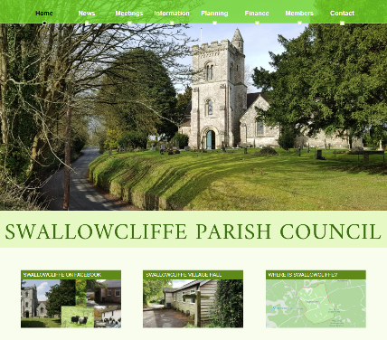
On behalf of Swallowcliffe Parish Council, welcome to Swallowcliffe.
What we do
Your parish council is here to organise services to and representation for residents of Swallowcliffe.
It’s the first tier of government – a ‘local council’. (We have chosen to use the term ‘Parish Council’ to best reflect our community. Other first-tier councils use the term 'Neighbourhood Council', ‘Town Council’, or ‘Community Council’, but they mean the same thing.)
UK Government
Wiltshire county council
Swallowcliffe Parish Council
You can find a summary of where responsibility lies for a selection of service at the end of this leaflet.
Swallowcliffe Parish Council’s job is to democratically, responsibly, and transparently organise services and functions to the village, and to represent the village to other bodies (E.G. Wiltshire Council – for example for planning and highways matters). Some of these are mandated by acts of parliament, and others are good or expected practice.
Some examples of the council’s achievements are the installation of the Speed Indicator Devices, lobbying and paying for the 20MPH speed limit, improved ‘no HGV’ road signage, defibrillator installation and maintenance, provision of generator for the use of residents in case of power outages.
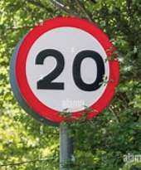
Who we are
There are five councillors, each one has a specific area of responsibility.
Councillors
Stephen Banas | Chair  Highways matters  HR  SID
Amanda Brockway | Vice chair  Footpaths & rights of way  Wiltshire Council South West Area Board
Nigel Cooke | Emergencies planning  HR  Village asset maintenance
Nick Oborne | Financial oversight  Village hall liaison
Sarah Taylor | Defibrillator  Parish Steward liaison
Non-Councillors
Lou Boothman | Environmental initiatives
Barry Fitzpatrick | Community web site  Flood warden
Matthew Phillips | Clerk  Responsible Financial Officer  Proper Officer  Generator readiness
To contact a councillor, send an email to: cllr_<lastname>@swallowcliffeparishcouncil.gov.uk, and to contact the clerk, send an email to: clerk@swallowcliffeparishcouncil.gov.uk.
Meetings
We hold five meetings a year, the dates of which are posted on the council’s website (http://www.swallowcliffeparishcouncil.gov.uk/), and our notice boards.
The May meeting is the annual meeting for the parish council where the agenda contains statutory items for governance etc. and in which the chair is elected.
You are welcome to observe at all meetings, and to make contributions at the start before the business items start proper.
You can find the agendas and minutes on our web site and notice boards.
Annual Parish Meeting
There is also an annual parish meeting in April, and while run by the parish council is not a meeting of the parish council, it is of the electors. Come to this meeting to find out the activities and achievements of the village’s community groups for the past year, and their plans for the next.
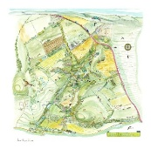Drawing by Jane Smart
Parish council democracy
Elections to office take place every four years.
The most recent election was in 2025, when, because the number of nominated candidates was not more than the number of available council seats, no poll was necessary.
We welcome more nominations – why not get involved? You could stand yourself or nominate others.
To be a councillor you must:
- be at least 18 years old,
- be a British citizen, Irish citizen, qualifying Commonwealth citizen, or a citizen of a country with a reciprocal voting and candidacy rights agreement with the UK,
- be on the electoral register for the parish or have lived in the parish (or within 3 miles of it) for the past 12 months, or have worked in the parish for the past 12 months, or have owned or rented land/premises in the parish for the past 12 months,
and must not:
- be subject to a bankruptcy order,
- have been disqualified from holding public office,
- have been convicted of a corrupt or illegal practice in an election,
- have received a custodial sentence of 3 months or more (including suspended sentences) within the last 5 years, or
- be employed or hold a paid office by or of the parish council.
Notices about forthcoming elections will be widely publicized.
Service highlights
Council services | Wiltshire Council | Swallowcliffe Parish Council
Byelaws | ✅ | ✅Can make byelaws for public walks and pleasure grounds
Charities |  | ✅ Can appoint trustees of parochial Charities
Consultation |  | ✅ Right to be consulted by principal councils
Crime prevention | ✅ | ✅ Can spend money on various crime prevention measures
Drainage | ✅ | ✅ Can deal with ditches and ponds
Education | ✅

Environmental health | ✅
General |  | ✅ Can incur expenditure on anything which in the council’s opinion is in the interests of the area or part of it or all or some of the inhabitants
Highways | ✅ | ✅ Maintain footpaths and Bridleways  ✅ Plant trees etc. and maintain roadside verge
Housing | ✅
Leisure & recreation | ✅
Libraries | ✅
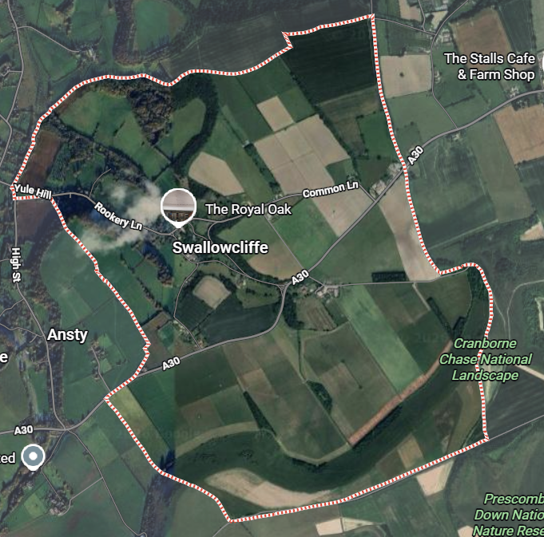
Map data © Google. Imagery © Airbus, Landsat / Copernicus, Maxar Technologies
Nuisances |  | ✅ Power to deal with offensive ponds, ditches and gutters
Passenger transport | ✅
Planning applications | ✅ | ✅ Right to be notified of planning application  ✅ Can make planning representations on behalf of the parish
Seats and shelters |  | ✅ Can provide roadside seats and shelter
Social care | ✅
Strategic planning | ✅
Taxation collection | ✅

Traffic calming | ✅ | ✅ Contribute to the cost of traffic calming measures
Transport planning | ✅
Village greens |  | ✅ Can maintain, and make bylaws for, and to prosecute for interference with village greens
Village signs |  | ✅ Can use decorative signs to inform visitors
Waste Collection | ✅
Waste disposal | ✅

© Swallowcliffe Parish Council 2026
Map data © Google. Imagery © Airbus, Landsat / Copernicus, Maxar Technologies

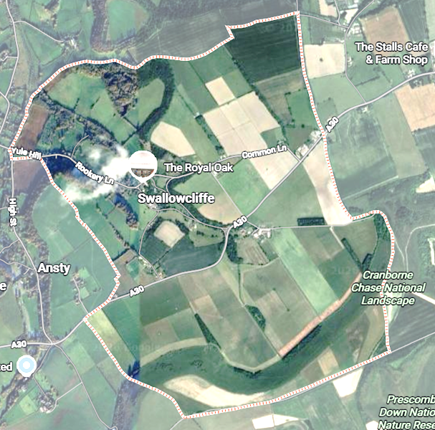

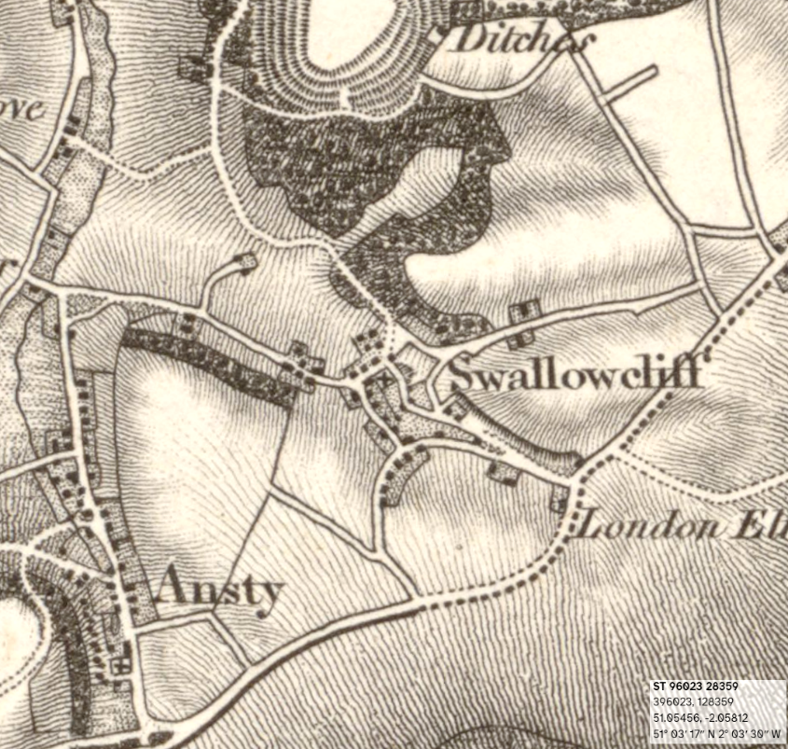
OS One-inch 1801-1869

